**Experiment No. 3b**

**Title :** Implementation of Fibonacci series using recursion

**Problem Statement :**Write C code to display the Fibonacci series till n values using recursion

**Algorithm :**

**Step 1:** Start.

**Step 2:** Declare a function fib() which takes integer argument which calls it recursively with the product of decrement 1 and decrement 2 of the number passed to it till it becomes less than or equal to 1.

**Step 3:** Input the number till which series has to be displayed.

**Step 4:** from 0 to the imputed number pass the numbers to fib() and display the returned values as Fibonacci series.

**Step 5:** Stop

**Program :**

#include<iostream>

using namespace std;

int fib(int n) //recursive fibonnacci function

{

if(n<=1)//exit condition of the function

{

return(n);

}

else //recursive function call till exit condition gets true

return((fib(n-1)+fib(n-2)));

}

int main()

{

int n,i=0;

cout<<"**** F I B O N A C C I ****\n";

cout<<"\nEnter the number of terms for Fibonacci series:";

cin>>n;//input n value

cout<<"\nFibonacci sequence is as follows : \n";

while(i<n)//display the fibonacci of i till n

{

cout<<" "<<fib(i);

i++;//increment i

}

return 0;

}

**Output :**

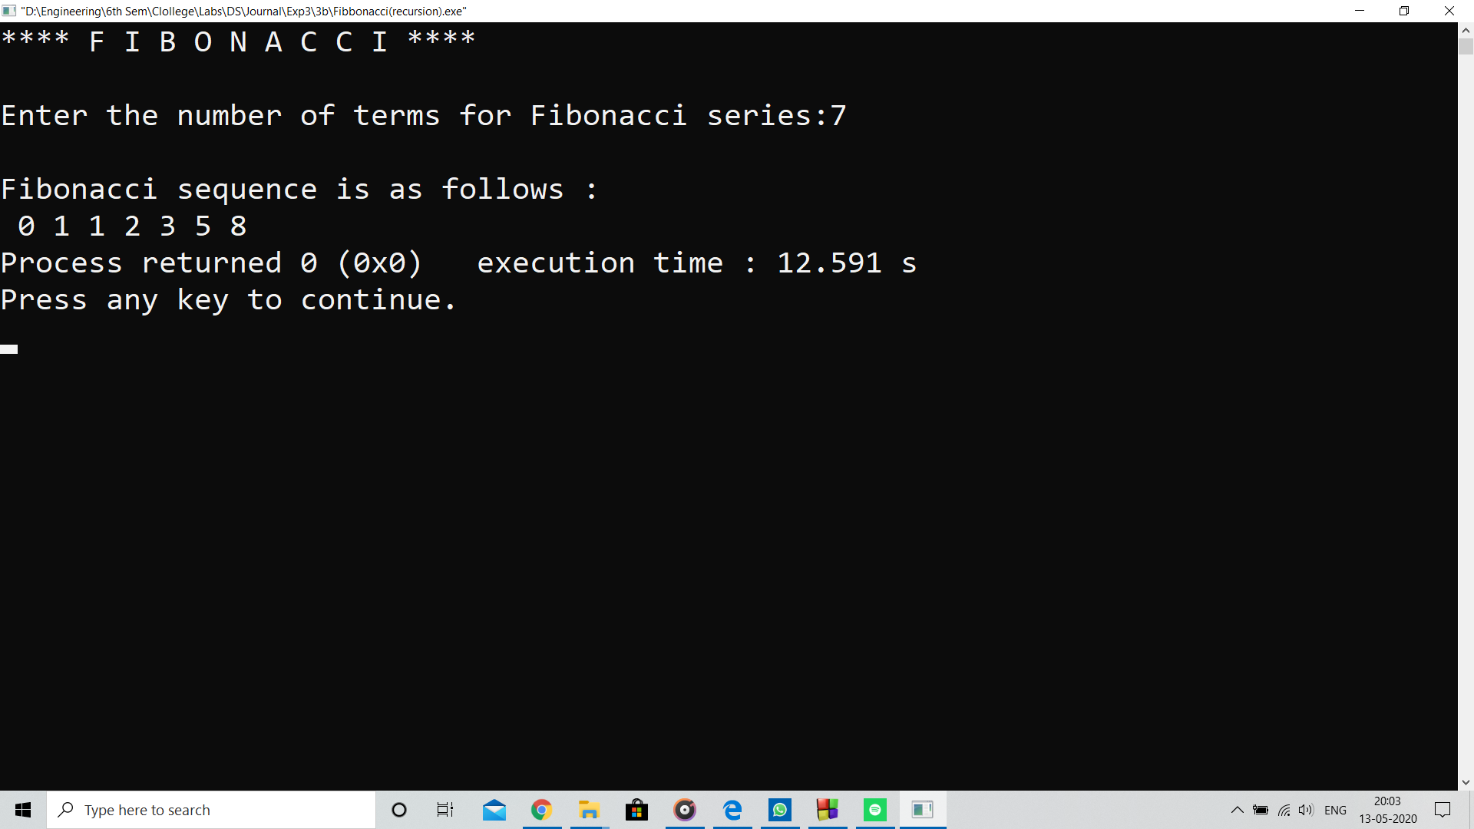

**Analysis :**

Program computes Fibonacci using recursive calls which is more expensive process compared to for loops as the control flow remains in the same context in for loops.

**Limitation :**

Program cannot print series in desired range it starts with 0.